Project: EHR SOFA — prediction of mortality among ventilated

Sensitivity analysis, excluded patients with CKD & ESRD at admission

October 27, 2021

## Conditional Tree

### SOFA + all components

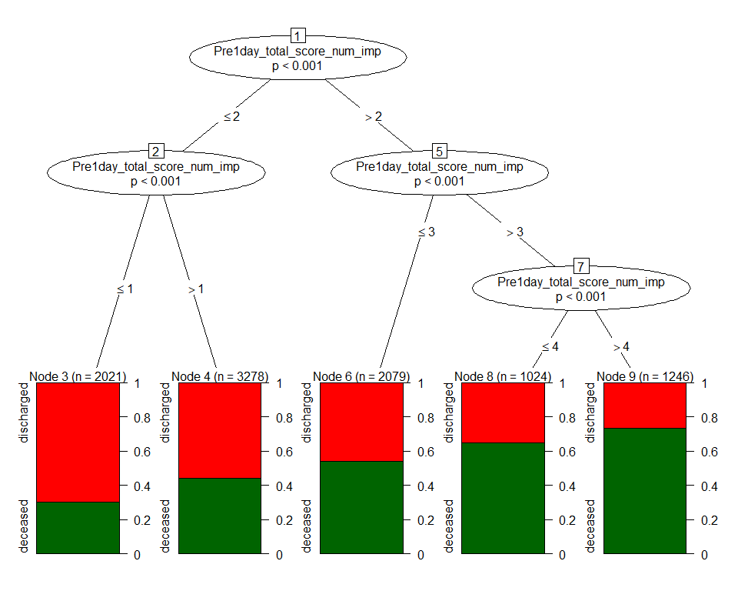

|  |  |  |
| --- | --- | --- |
| Variable | AUC.train | AUC.test |
| SOFA + all components | 0.654 (0.643,0.664) | 0.652 (0.637,0.667) |

### SOFA alone



|  |  |  |
| --- | --- | --- |
| Variable | AUC.train | AUC.test |
| SOFA | 0.654 (0.643,0.664) | 0.652 (0.637,0.667) |

### Categorical SOFA alone

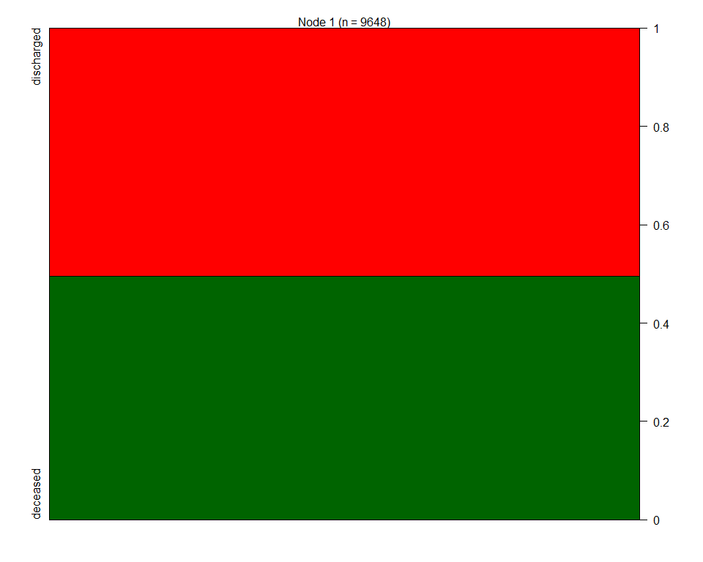

|  |  |  |
| --- | --- | --- |
| Variable | AUC.train | AUC.test |
| SOFA categories | 0.5 (0.5,0.5) | 0.5 (0.5,0.5) |

### Pulmonary sofa alone

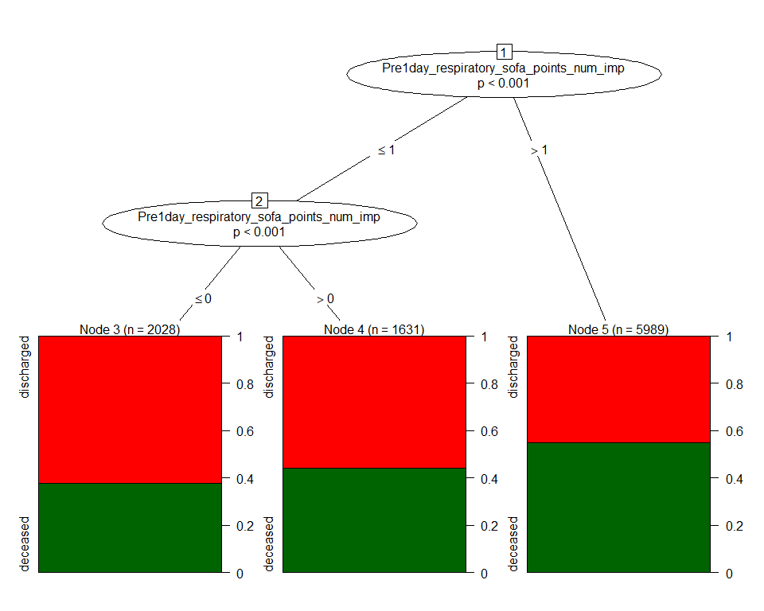

|  |  |  |
| --- | --- | --- |
| Variable | AUC.train | AUC.test |
| Pulmonary | 0.572 (0.562,0.582) | 0.583 (0.569,0.597) |

### Renal sofa alone



|  |  |  |
| --- | --- | --- |
| Variable | AUC.train | AUC.test |
| Renal | 0.5 (0.5,0.5) | 0.5 (0.5,0.5) |

### Heme sofa alone

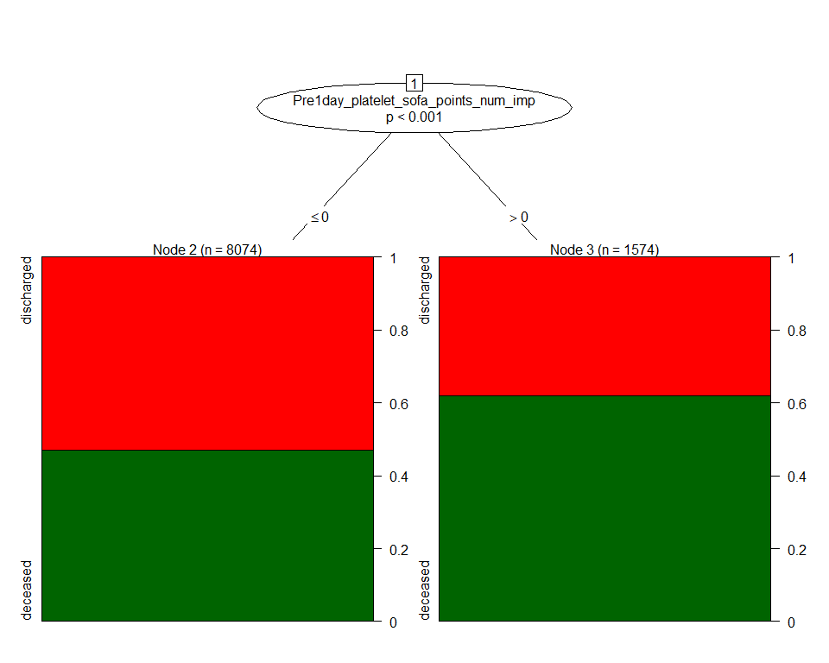

|  |  |  |
| --- | --- | --- |
| Variable | AUC.train | AUC.test |
| Heme | 0.541 (0.533,0.548) | 0.534 (0.523,0.544) |

### Neuro sofa alone

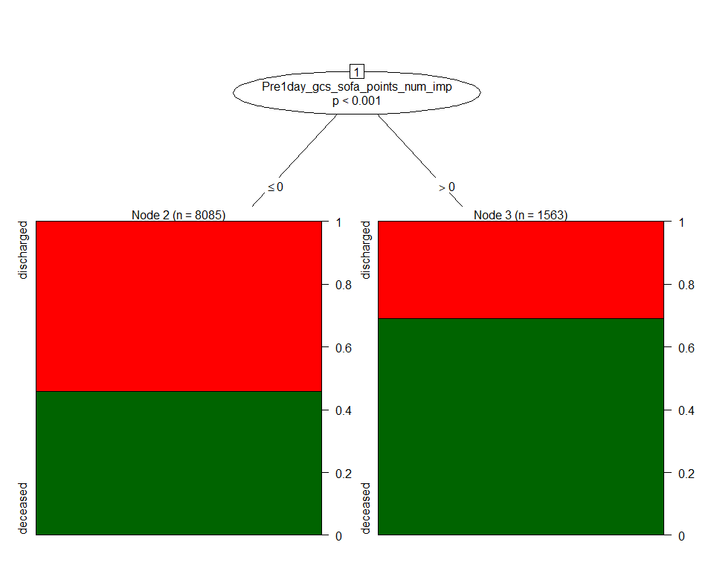

|  |  |  |
| --- | --- | --- |
| Variable | AUC.train | AUC.test |
| Neuro | 0.563 (0.556,0.571) | 0.564 (0.554,0.575) |

### Liver sofa alone

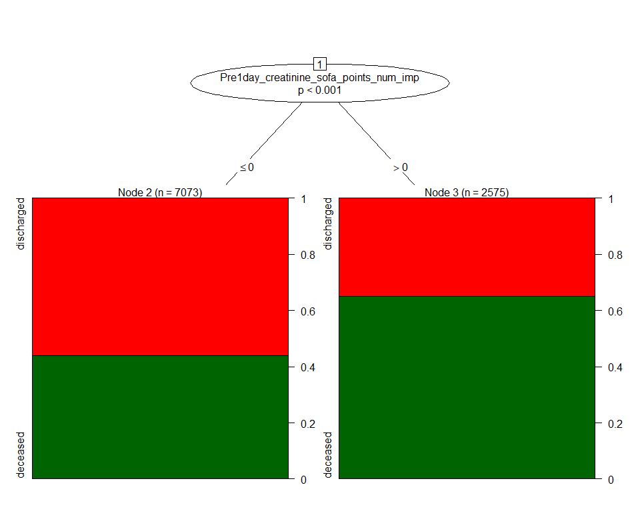

|  |  |  |
| --- | --- | --- |
| Variable | AUC.train | AUC.test |
| Liver | 0.582 (0.574,0.591) | 0.573 (0.56,0.585) |

### Cardio sofa alone

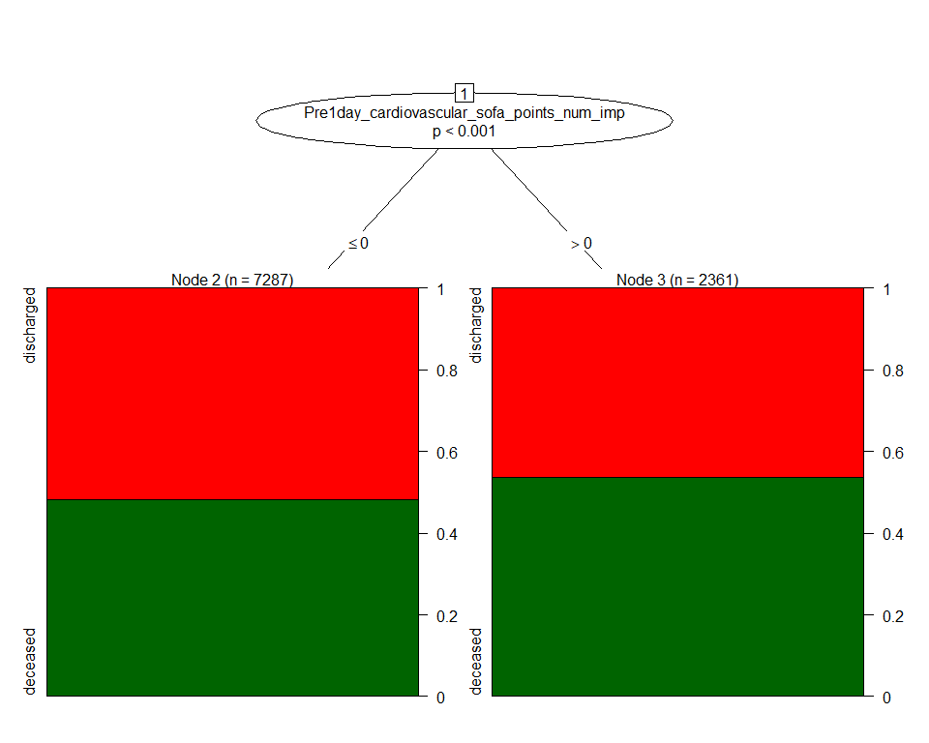

|  |  |  |
| --- | --- | --- |
| Variable | AUC.train | AUC.test |
| Cardio | 0.52 (0.512,0.529) | 0.52 (0.508,0.532) |

### SOFA + all components + age + gender + obesity +diabetes + hypertension

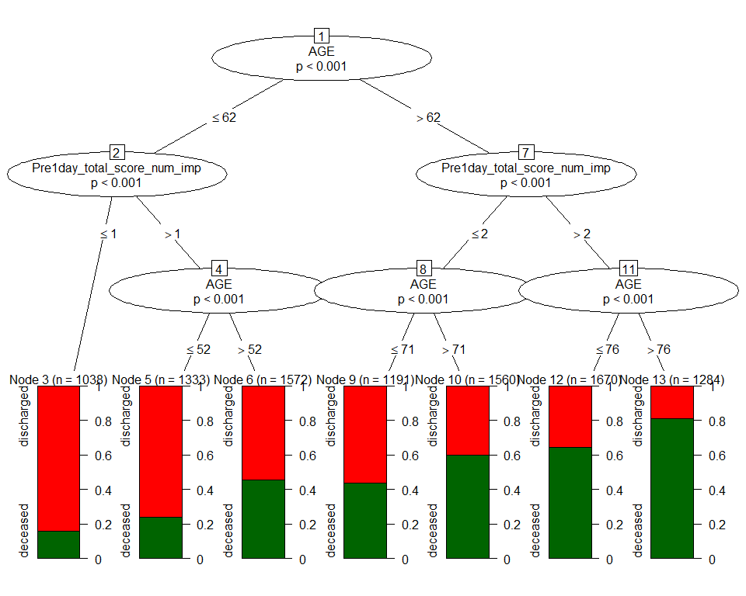

|  |  |  |
| --- | --- | --- |
| Variable | AUC.train | AUC.test |
| SOFA & all components + covariates | 0.726 (0.716,0.736) | 0.716 (0.701,0.73) |

### SOFA + age + gender + obesity +diabetes + hypertension



|  |  |  |
| --- | --- | --- |
| Variable | AUC.train | AUC.test |
| SOFA + covariates | 0.726 (0.716,0.736) | 0.716 (0.701,0.73) |

### Pulmonary sofa + age + gender + obesity +diabetes + hypertension

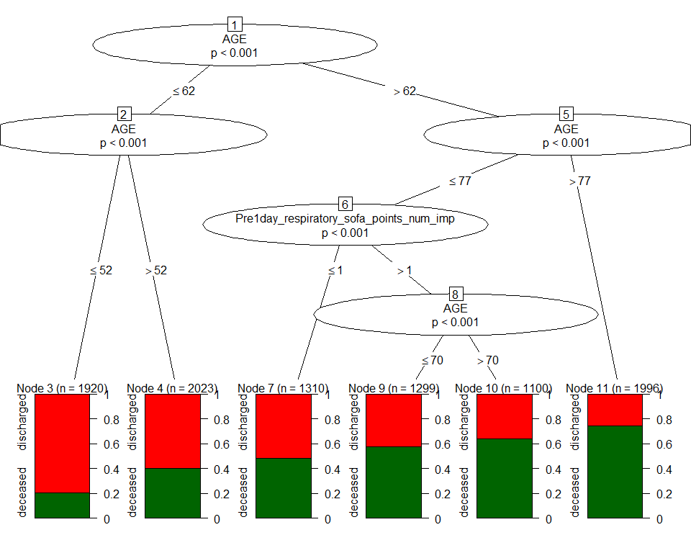

|  |  |  |
| --- | --- | --- |
| Variable | AUC.train | AUC.test |
| Pulmonary sofa + covariates | 0.71 (0.7,0.72) | 0.705 (0.69,0.719) |

### Renal sofa + age + gender + obesity +diabetes + hypertension

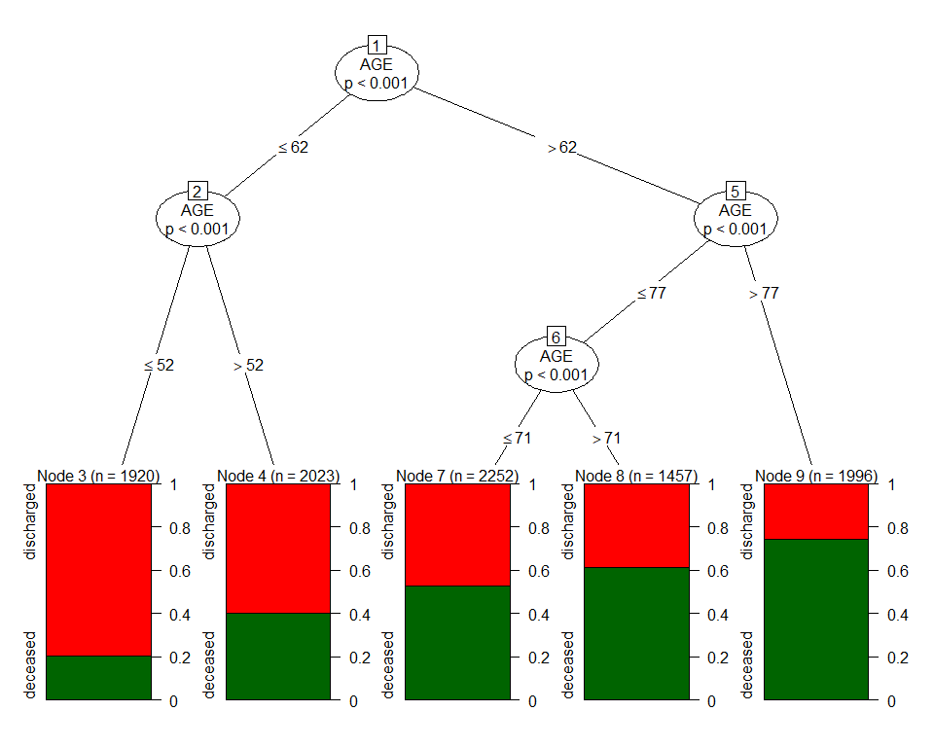

|  |  |  |
| --- | --- | --- |
| Variable | AUC.train | AUC.test |
| Renal sofa + covariates | 0.706 (0.696,0.716) | 0.7 (0.685,0.714) |

### Heme sofa + age + gender + obesity +diabetes + hypertension



|  |  |  |
| --- | --- | --- |
| Variable | AUC.train | AUC.test |
| Heme sofa + covariates | 0.706 (0.696,0.716) | 0.7 (0.685,0.714) |

### Neuro sofa + age + gender + obesity +diabetes + hypertension



|  |  |  |
| --- | --- | --- |
| Variable | AUC.train | AUC.test |
| Neuro sofa + covariates | 0.706 (0.696,0.716) | 0.7 (0.685,0.714) |

### Liver sofa + age + gender + obesity +diabetes + hypertension

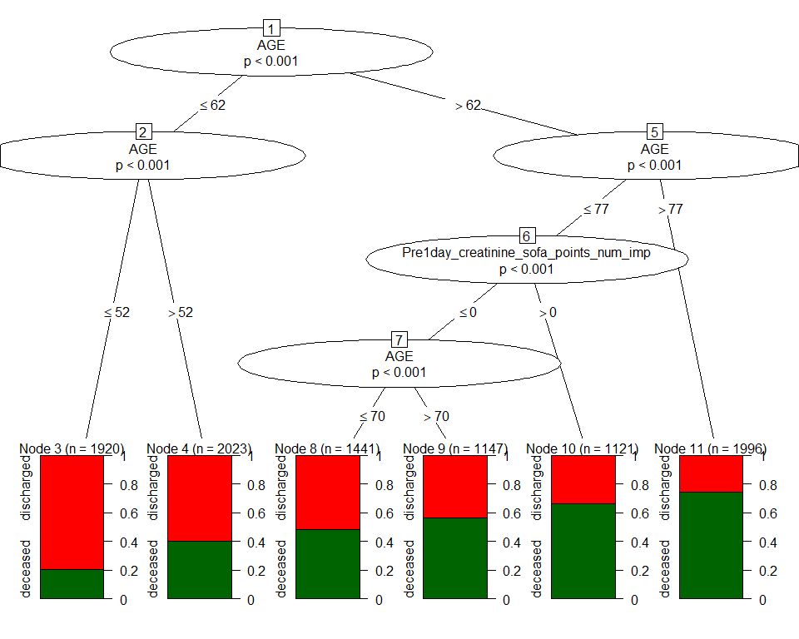

|  |  |  |
| --- | --- | --- |
| Variable | AUC.train | AUC.test |
| Liver sofa + covariates | 0.712 (0.702,0.722) | 0.705 (0.691,0.72) |

### Cardio sofa + age + gender + obesity +diabetes + hypertension



|  |  |  |
| --- | --- | --- |
| Variable | AUC.train | AUC.test |
| Cardio sofa + covariates | 0.706 (0.696,0.716) | 0.7 (0.685,0.714) |

### age



|  |  |  |
| --- | --- | --- |
| Variable | AUC.train | AUC.test |
| age | 0.706 (0.696,0.716) | 0.7 (0.685,0.714) |

### age + SOFA



|  |  |  |
| --- | --- | --- |
| Variable | AUC.train | AUC.test |
| age + SOFA | 0.726 (0.716,0.736) | 0.716 (0.701,0.73) |

### age + Categorical SOFA



|  |  |  |
| --- | --- | --- |
| Variable | AUC.train | AUC.test |
| age + Categorical SOFA | 0.706 (0.696,0.716) | 0.7 (0.685,0.714) |

### age + elixhauser score



|  |  |  |
| --- | --- | --- |
| Variable | AUC.train | AUC.test |
| age + elixhauser score | 0.706 (0.696,0.716) | 0.7 (0.685,0.714) |

### age + gender + obesity +diabetes + hypertension



|  |  |  |
| --- | --- | --- |
| Variable | AUC.train | AUC.test |
| covariates | 0.706 (0.696,0.716) | 0.7 (0.685,0.714) |

### SOFA + elixhauser score



|  |  |  |
| --- | --- | --- |
| Variable | AUC.train | AUC.test |
| SOFA + elixhauser score | 0.654 (0.643,0.664) | 0.652 (0.637,0.667) |

### Categories SOFA + elixhauser score

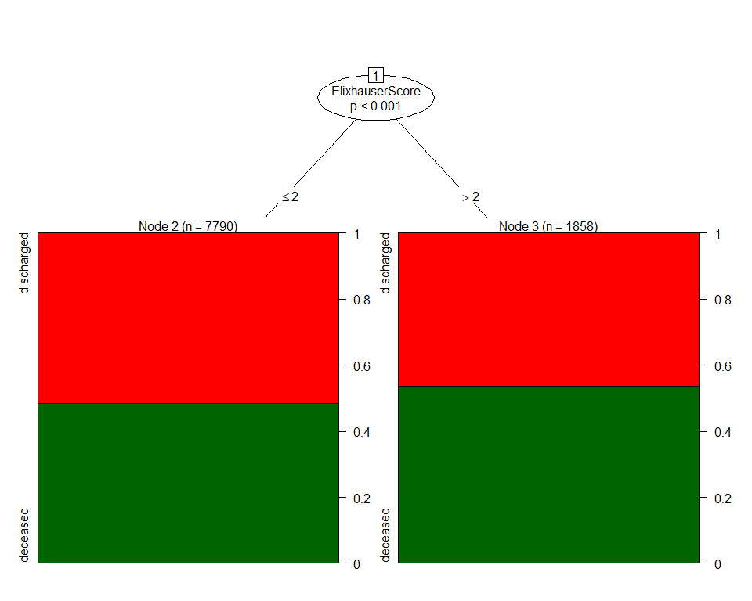

|  |  |  |
| --- | --- | --- |
| Variable | AUC.train | AUC.test |
| Categories SOFA + elixhauser score | 0.516 (0.508,0.524) | 0.509 (0.498,0.52) |

### SOFA + age + elixhauser score



|  |  |  |
| --- | --- | --- |
| Variable | AUC.train | AUC.test |
| SOFA + age + elixhauser score | 0.726 (0.716,0.736) | 0.716 (0.701,0.73) |

### SOFA + all components + age + elixhauser score



|  |  |  |
| --- | --- | --- |
| Variable | AUC.train | AUC.test |
| SOFA + all components + age + elixhauser score | 0.726 (0.716,0.736) | 0.716 (0.701,0.73) |

### Pulmonary sofa + age + elixhauser score



|  |  |  |
| --- | --- | --- |
| Variable | AUC.train | AUC.test |
| Pulmonary sofa + age + elixhauser score | 0.71 (0.7,0.72) | 0.705 (0.69,0.719) |

### Renal sofa + age + elixhauser score



|  |  |  |
| --- | --- | --- |
| Variable | AUC.train | AUC.test |
| Renal sofa + age + elixhauser score | 0.706 (0.696,0.716) | 0.7 (0.685,0.714) |

### Heme sofa + age + elixhauser score



|  |  |  |
| --- | --- | --- |
| Variable | AUC.train | AUC.test |
| Heme sofa + age + elixhauser score | 0.706 (0.696,0.716) | 0.7 (0.685,0.714) |

### Neuro sofa + age + elixhauser score



|  |  |  |
| --- | --- | --- |
| Variable | AUC.train | AUC.test |
| Neuro sofa + age + elixhauser score | 0.706 (0.696,0.716) | 0.7 (0.685,0.714) |

### Liver sofa + age + elixhauser score



|  |  |  |
| --- | --- | --- |
| Variable | AUC.train | AUC.test |
| Liver sofa + age + elixhauser score | 0.712 (0.702,0.722) | 0.705 (0.691,0.72) |

### Cardio sofa + age + elixhauser score



|  |  |  |
| --- | --- | --- |
| Variable | AUC.train | AUC.test |
| Cardio sofa + age + elixhauser score | 0.706 (0.696,0.716) | 0.7 (0.685,0.714) |

## GLM model

### SOFA alone

|  |  |  |  |  |
| --- | --- | --- | --- | --- |
| Variable | AUC.train | AUC.test | term | OR |
| SOFA | 0.66 (0.65,0.67) | 0.66 (0.64,0.67) | Pre1day_total_score_num_imp | 1.41 (1.37, 1.45) |

### Categorical SOFA alone

|  |  |  |  |  |
| --- | --- | --- | --- | --- |
| Variable | AUC.train | AUC.test | term | OR |
| Categorical SOFA | 0.54 (0.53,0.54) | 0.54 (0.53,0.54) | FourGrp_Pre1day_total_score_num_imp6 >= sofa <9 | 3.48 (2.88, 4.24) |
| Categorical SOFA | 0.54 (0.53,0.54) | 0.54 (0.53,0.54) | FourGrp_Pre1day_total_score_num_imp9 >= sofa <12 | 4.77 (2.88, 8.37) |
| Categorical SOFA | 0.54 (0.53,0.54) | 0.54 (0.53,0.54) | FourGrp_Pre1day_total_score_num_impsofa >= 12 | 17.79 (3.63, 321.16) |

### Pulmonary +Renal + Heme + Neuro + Liver + Cardio

|  |  |  |  |  |
| --- | --- | --- | --- | --- |
| Variable | AUC.train | AUC.test | term | OR |
| All SOFA components | 0.67 (0.66,0.68) | 0.67 (0.65,0.68) | Pre1day_bilirubin_sofa_points_num_imp | 1.46 (1.29, 1.66) |
| All SOFA components | 0.67 (0.66,0.68) | 0.67 (0.65,0.68) | Pre1day_creatinine_sofa_points_num_imp | 1.47 (1.39, 1.55) |
| All SOFA components | 0.67 (0.66,0.68) | 0.67 (0.65,0.68) | Pre1day_platelet_sofa_points_num_imp | 1.44 (1.32, 1.57) |
| All SOFA components | 0.67 (0.66,0.68) | 0.67 (0.65,0.68) | Pre1day_gcs_sofa_points_num_imp | 1.68 (1.55, 1.82) |
| All SOFA components | 0.67 (0.66,0.68) | 0.67 (0.65,0.68) | Pre1day_cardiovascular_sofa_points_num_imp | 0.98 (0.91, 1.05) |
| All SOFA components | 0.67 (0.66,0.68) | 0.67 (0.65,0.68) | Pre1day_respiratory_sofa_points_num_imp | 1.53 (1.45, 1.61) |

### SOFA + age + gender + obesity +diabetes + hypertension

|  |  |  |  |  |
| --- | --- | --- | --- | --- |
| Variable | AUC.train | AUC.test | term | OR |
| SOFA + covariates | 0.75 (0.74,0.76) | 0.74 (0.73,0.76) | Pre1day_total_score_num_imp | 1.33 (1.3, 1.37) |
| SOFA + covariates | 0.75 (0.74,0.76) | 0.74 (0.73,0.76) | AGE | 1.06 (1.05, 1.06) |
| SOFA + covariates | 0.75 (0.74,0.76) | 0.74 (0.73,0.76) | GENDERMale | 1.14 (1.04, 1.24) |
| SOFA + covariates | 0.75 (0.74,0.76) | 0.74 (0.73,0.76) | GENDERUnknown | 1.26 (0.6, 2.65) |
| SOFA + covariates | 0.75 (0.74,0.76) | 0.74 (0.73,0.76) | Obesity | 0.93 (0.79, 1.09) |
| SOFA + covariates | 0.75 (0.74,0.76) | 0.74 (0.73,0.76) | Diabetes | 1.17 (1.04, 1.31) |
| SOFA + covariates | 0.75 (0.74,0.76) | 0.74 (0.73,0.76) | Hyptertension | 0.84 (0.75, 0.94) |

### Pulmonary +Renal + Heme + Neuro + Liver + Cardio + age + gender + obesity +diabetes + hypertension

|  |  |  |  |  |
| --- | --- | --- | --- | --- |
| Variable | AUC.train | AUC.test | term | OR |
| All SOFA components + covariates | 0.75 (0.74,0.76) | 0.75 (0.73,0.76) | Pre1day_bilirubin_sofa_points_num_imp | 1.6 (1.41, 1.83) |
| All SOFA components + covariates | 0.75 (0.74,0.76) | 0.75 (0.73,0.76) | Pre1day_creatinine_sofa_points_num_imp | 1.34 (1.27, 1.41) |
| All SOFA components + covariates | 0.75 (0.74,0.76) | 0.75 (0.73,0.76) | Pre1day_platelet_sofa_points_num_imp | 1.38 (1.27, 1.51) |
| All SOFA components + covariates | 0.75 (0.74,0.76) | 0.75 (0.73,0.76) | Pre1day_gcs_sofa_points_num_imp | 1.36 (1.25, 1.48) |
| All SOFA components + covariates | 0.75 (0.74,0.76) | 0.75 (0.73,0.76) | Pre1day_cardiovascular_sofa_points_num_imp | 1.01 (0.93, 1.1) |
| All SOFA components + covariates | 0.75 (0.74,0.76) | 0.75 (0.73,0.76) | Pre1day_respiratory_sofa_points_num_imp | 1.5 (1.42, 1.59) |
| All SOFA components + covariates | 0.75 (0.74,0.76) | 0.75 (0.73,0.76) | AGE | 1.06 (1.05, 1.06) |
| All SOFA components + covariates | 0.75 (0.74,0.76) | 0.75 (0.73,0.76) | GENDERMale | 1.11 (1.01, 1.22) |
| All SOFA components + covariates | 0.75 (0.74,0.76) | 0.75 (0.73,0.76) | GENDERUnknown | 1.27 (0.61, 2.69) |
| All SOFA components + covariates | 0.75 (0.74,0.76) | 0.75 (0.73,0.76) | Obesity | 0.92 (0.78, 1.08) |
| All SOFA components + covariates | 0.75 (0.74,0.76) | 0.75 (0.73,0.76) | Diabetes | 1.17 (1.04, 1.32) |
| All SOFA components + covariates | 0.75 (0.74,0.76) | 0.75 (0.73,0.76) | Hyptertension | 0.83 (0.74, 0.93) |

### SOFA + age + elixhauser score

|  |  |  |  |  |
| --- | --- | --- | --- | --- |
| Variable | AUC.train | AUC.test | term | OR |
| SOFA + age + elixhauser score | 0.75 (0.74,0.76) | 0.74 (0.73,0.76) | Pre1day_total_score_num_imp | 1.34 (1.3, 1.38) |
| SOFA + age + elixhauser score | 0.75 (0.74,0.76) | 0.74 (0.73,0.76) | AGE | 1.06 (1.05, 1.06) |
| SOFA + age + elixhauser score | 0.75 (0.74,0.76) | 0.74 (0.73,0.76) | ElixhauserScore | 1 (0.97, 1.03) |

### Pulmonary +Renal + Heme + Neuro + Liver + Cardio + age + elixhauser score

|  |  |  |  |  |
| --- | --- | --- | --- | --- |
| Variable | AUC.train | AUC.test | term | OR |
| SOFA components + age + elixhauser score | 0.75 (0.74,0.76) | 0.74 (0.73,0.76) | Pre1day_bilirubin_sofa_points_num_imp | 1.62 (1.42, 1.84) |
| SOFA components + age + elixhauser score | 0.75 (0.74,0.76) | 0.74 (0.73,0.76) | Pre1day_creatinine_sofa_points_num_imp | 1.35 (1.28, 1.42) |
| SOFA components + age + elixhauser score | 0.75 (0.74,0.76) | 0.74 (0.73,0.76) | Pre1day_platelet_sofa_points_num_imp | 1.39 (1.27, 1.52) |
| SOFA components + age + elixhauser score | 0.75 (0.74,0.76) | 0.74 (0.73,0.76) | Pre1day_gcs_sofa_points_num_imp | 1.37 (1.26, 1.49) |
| SOFA components + age + elixhauser score | 0.75 (0.74,0.76) | 0.74 (0.73,0.76) | Pre1day_cardiovascular_sofa_points_num_imp | 1.01 (0.93, 1.1) |
| SOFA components + age + elixhauser score | 0.75 (0.74,0.76) | 0.74 (0.73,0.76) | Pre1day_respiratory_sofa_points_num_imp | 1.5 (1.42, 1.58) |
| SOFA components + age + elixhauser score | 0.75 (0.74,0.76) | 0.74 (0.73,0.76) | AGE | 1.06 (1.05, 1.06) |
| SOFA components + age + elixhauser score | 0.75 (0.74,0.76) | 0.74 (0.73,0.76) | ElixhauserScore | 1 (0.97, 1.03) |

### age

|  |  |  |  |  |
| --- | --- | --- | --- | --- |
| Variable | AUC.train | AUC.test | term | OR |
| age | 0.71 (0.7,0.72) | 0.71 (0.7,0.73) | AGE | 1.06 (1.06, 1.06) |

### age + SOFA

|  |  |  |  |  |
| --- | --- | --- | --- | --- |
| Variable | AUC.train | AUC.test | term | OR |
| age + SOFA | 0.75 (0.74,0.76) | 0.74 (0.73,0.76) | AGE | 1.06 (1.05, 1.06) |
| age + SOFA | 0.75 (0.74,0.76) | 0.74 (0.73,0.76) | Pre1day_total_score_num_imp | 1.34 (1.3, 1.38) |

### age + Categories SOFA

|  |  |  |  |  |
| --- | --- | --- | --- | --- |
| Variable | AUC.train | AUC.test | term | OR |
| age + Categories SOFA | 0.73 (0.72,0.74) | 0.72 (0.71,0.73) | AGE | 1.06 (1.06, 1.06) |
| age + Categories SOFA | 0.73 (0.72,0.74) | 0.72 (0.71,0.73) | FourGrp_Pre1day_total_score_num_imp6 >= sofa <9 | 3.1 (2.53, 3.81) |
| age + Categories SOFA | 0.73 (0.72,0.74) | 0.72 (0.71,0.73) | FourGrp_Pre1day_total_score_num_imp9 >= sofa <12 | 4.88 (2.87, 8.76) |
| age + Categories SOFA | 0.73 (0.72,0.74) | 0.72 (0.71,0.73) | FourGrp_Pre1day_total_score_num_impsofa >= 12 | 21.29 (4.19, 389.17) |

### age + Elixhauser score

|  |  |  |  |  |
| --- | --- | --- | --- | --- |
| Variable | AUC.train | AUC.test | term | OR |
| age + Elixhauser score | 0.71 (0.7,0.72) | 0.71 (0.7,0.73) | AGE | 1.06 (1.06, 1.06) |
| age + Elixhauser score | 0.71 (0.7,0.72) | 0.71 (0.7,0.73) | ElixhauserScore | 1.02 (0.99, 1.04) |

### SOFA + Elixhauser score

|  |  |  |  |  |
| --- | --- | --- | --- | --- |
| Variable | AUC.train | AUC.test | term | OR |
| SOFA + Elixhauser score | 0.66 (0.65,0.67) | 0.66 (0.64,0.67) | Pre1day_total_score_num_imp | 1.41 (1.37, 1.45) |
| SOFA + Elixhauser score | 0.66 (0.65,0.67) | 0.66 (0.64,0.67) | ElixhauserScore | 1.05 (1.02, 1.07) |

### Categories SOFA + Elixhauser score

|  |  |  |  |  |
| --- | --- | --- | --- | --- |
| Variable | AUC.train | AUC.test | term | OR |
| Categories SOFA + Elixhauser score | 0.56 (0.55,0.57) | 0.55 (0.54,0.57) | FourGrp_Pre1day_total_score_num_imp6 >= sofa <9 | 3.45 (2.86, 4.2) |
| Categories SOFA + Elixhauser score | 0.56 (0.55,0.57) | 0.55 (0.54,0.57) | FourGrp_Pre1day_total_score_num_imp9 >= sofa <12 | 4.71 (2.84, 8.26) |
| Categories SOFA + Elixhauser score | 0.56 (0.55,0.57) | 0.55 (0.54,0.57) | FourGrp_Pre1day_total_score_num_impsofa >= 12 | 17.49 (3.57, 315.83) |
| Categories SOFA + Elixhauser score | 0.56 (0.55,0.57) | 0.55 (0.54,0.57) | ElixhauserScore | 1.06 (1.03, 1.09) |

## Calibration plot

Produced calibration plots for logistic regression models using Age, SOFA, SOFA categories, SOFA + Age, or SOFA + Covariates as the regressors.

## ROC plot

Generated ROC curves for continuous SOFA, categorized SOFA, Age alone and SOFA + Age

DeLong's test for two correlated ROC curves  
  
data: roc.train.sofa and roc.train.sofaCat  
Z = 23.77, p-value < 2.2e-16  
alternative hypothesis: true difference in AUC is not equal to 0  
sample estimates:  
AUC of roc1 AUC of roc2   
 65.54964 53.98152

DeLong's test for two correlated ROC curves  
  
data: roc.train.sofa and roc.train.sofaAge  
Z = -18.977, p-value < 2.2e-16  
alternative hypothesis: true difference in AUC is not equal to 0  
sample estimates:  
AUC of roc1 AUC of roc2   
 65.54964 74.66359

DeLong's test for two ROC curves  
  
data: roc.train.age and roc.train.sofaAge  
D = -4.6328, df = 19247, p-value = 3.631e-06  
alternative hypothesis: true difference in AUC is not equal to 0  
sample estimates:  
AUC of roc1 AUC of roc2   
 71.36066 74.66359

DeLong's test for two correlated ROC curves  
  
data: roc.test.sofa and roc.test.sofaCat  
Z = 17.331, p-value < 2.2e-16  
alternative hypothesis: true difference in AUC is not equal to 0  
sample estimates:  
AUC of roc1 AUC of roc2   
 65.54339 53.54844

DeLong's test for two correlated ROC curves  
  
data: roc.test.sofa and roc.test.sofaAge  
Z = -12.774, p-value < 2.2e-16  
alternative hypothesis: true difference in AUC is not equal to 0  
sample estimates:  
AUC of roc1 AUC of roc2   
 65.54339 74.14340

DeLong's test for two correlated ROC curves  
  
data: roc.test.age and roc.test.sofaAge  
Z = -7.4286, p-value = 1.098e-13  
alternative hypothesis: true difference in AUC is not equal to 0  
sample estimates:  
AUC of roc1 AUC of roc2   
 71.10757 74.14340